Lab 6.2 Using env

- Create a pod-definition.yml file as below:
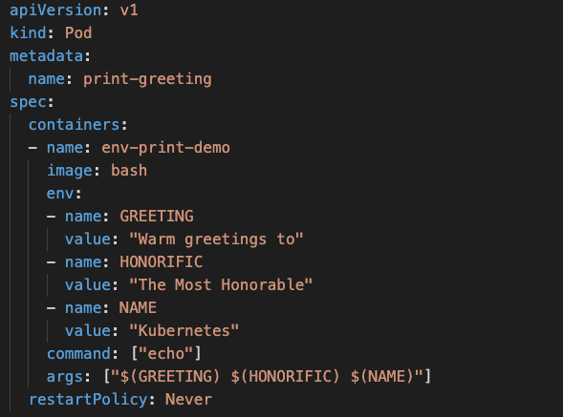

- Create the Pod
kubectl create -f pod-definition.yml

- Check the Logs in the Pod
kubectl logs -f print-greeting

- Delete the pod
kubectl delete pod/print-greeting

